WEEK 3 ASSIGNMENT - ENTITY FRAMEWORK CORE 8.0
Cognizant Digital Nurture 4.0 – Week 3 Assessment
Entity Framework Core 8.0 – Retail Inventory System
Submitted By: Abinaya S
Track: .NET Full Stack Engineering (FSE)
Date: 5th JULY 2025

Table of Contents:
1. Introduction
2. Lab 1: Understanding ORM
3. Lab 2: Setting Up the DbContext
4. Lab 3: Creating and Applying Migrations
5. Lab 4: Inserting Data
6. Lab 5: Retrieving Data
7. Lab 6: Updating & Deleting Records
8. Lab 7: LINQ Queries
9. Console Output
10. GitHub Repository
11. Conclusion

Introduction:
This report outlines the implementation of a Retail Inventory System using Entity Framework Core 8.0, as part of Week 3 assignment for the Cognizant Digital Nurture 4.0 Program.
The system includes product data modeling, database operations using EF Core, and LINQ queries for data analysis. All labs from 1 to 7 are covered.

Lab-wise Descriptions with Screenshots
Lab 1 – Understanding ORM
Description: Created Product.cs model with Id, Name, Quantity, Price.
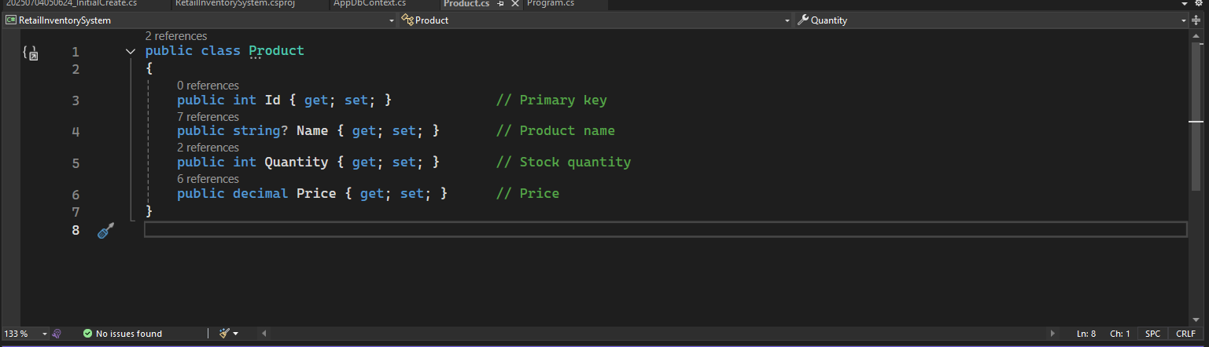 Figure 1 – Product.cs class defining the Product entity.

Lab 2 – Setting Up the Database Context

Description: Set up AppDbContext class and connected to RetailDB using LocalDB.
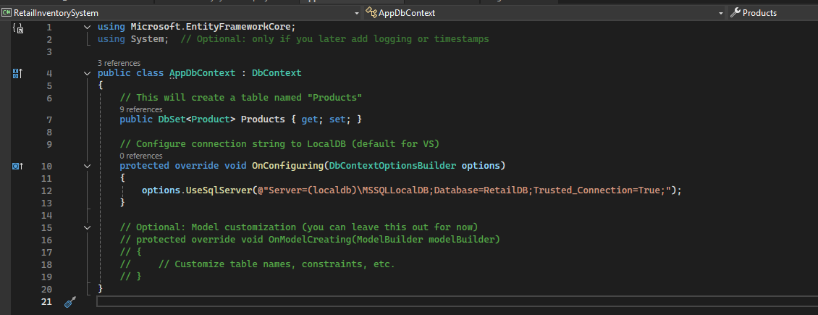
Figure 2 – AppDbContext class with connection string.

options.UseSqlServer(@"Server=(localdb)\MSSQLLocalDB;Database=RetailDB;Trusted_Connection=True;");

Lab 3 – EF Core CLI Migrations

Description: Executed Add-Migration and Update-Database to apply schema.
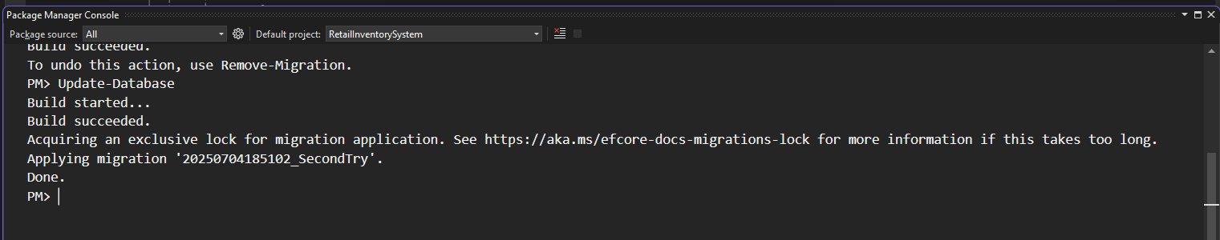
Figure 3 – Output of Add-Migration and Update-Database in Package Manager Console.

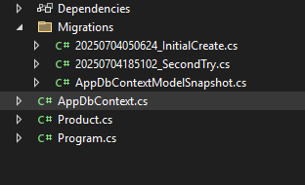
Figure 4 – Auto-generated Migrations folder after successful migration.

Lab 5 – Retrieving Data
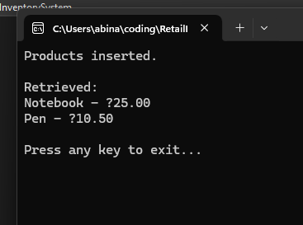
Figure 5 – Output showing retrieved product list from database.

Lab 7 – Writing Queries with LINQ
